OUTREACH SCHOOLS EXAMINATION BOARD
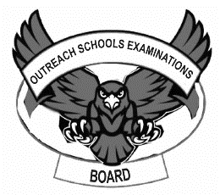
BEGINNING OF TERM III EXAMINATION 2023
PRIMARY TWO
LITERACY 1B

My name is __________________________________________

I am in ______________________________________________

My school is _________________________________________
SECTION A:
- Who heads a school?
_______________________________________________________
- Why do people fence their homes?
_________________________________________________________
- Mention two items found in a bedroom.
- ___________________________________________________
- __________________________________________________
- Which traffic light allows drivers to move?
_________________________________________________________
- Mention two activities done by farmers in a wet
season.
- ____________________________________________________
- ____________________________________________________
- Who takes care of sick people at school?
_________________________________________________________
- How are carpenters important in a community?
_________________________________________________________
- Draw a traffic road sign for parking.

- Why do people make pots?
_________________________________________________________
- In which type of family do we find uncles?
________________________________________________________
- Mention two animals kept at home for transport.
- ______________________ (ii) ______________________
- Write one cultural activity practised in a community.
_________________________________________________________
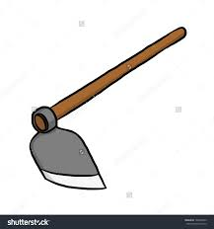
- Match correctly.
used for collecting rubbish.

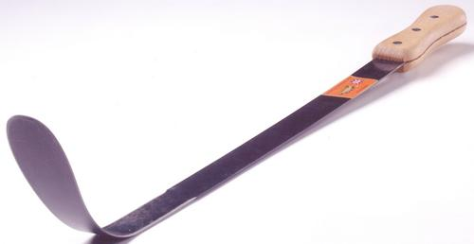
used for watering crops.


used for slashing.
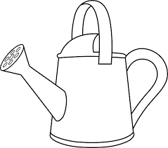

used for digging.
- Which animal is kept at home for security?
_________________________________________________________
- Write two symbols of a school.
- ____________________________________________________
- ____________________________________________________
- Give the importance of a clock in a classroom.
_________________________________________________________
- Write one place where we find wild animals.
________________________________________________________
- Give two basic needs of people.
- ______________________ (ii) ______________________
- Why do we need class rules?
________________________________________________________
- Name one thing God created to give us light at night.
_________________________________________________________
- How does one become a member of God’s family?
_________________________________________________________
- What does the name Moses mean?
________________________________________________________
- How do parents show love to their children?
________________________________________________________
- Give one activity children do at home.
_________________________________________________________
SECTION B
- Match the means to the types of transport below.
Bus air transport.
Train road transport.
Ship railway transport.
Helicopter water transport.

- Name two things found in a kitchen.
(i)______________________ (ii) _________________________
- Give two things a school can buy from the community
around it.
- _____________________ (ii) ____________________________
- Why do we need these people at school?
- cooks _____________________________________________
- teachers ___________________________________________
- Name the type of weather where we use rain coats.
_________________________________________________________
- Mention two activities done by people in a community.
- _____________________ (ii)_________________________
- Name one part of house.
_________________________________________________________
- Give one cause of insecurity in our home.
_________________________________________________________
- (a) Why do people build houses?
_________________________________________________________
(b) Name these building materials below.
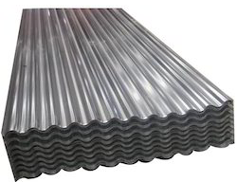 | 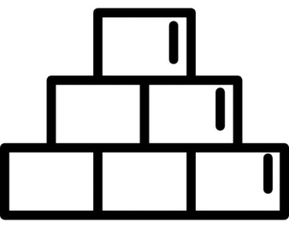 | 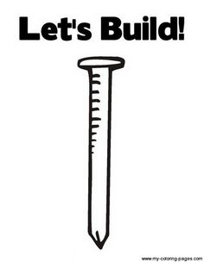

- Give one danger of pot holes on roads.
_________________________________________________________
- Name one important place in a community where people
go for treatment.
_________________________________________________________
END

